**Create Test Case**

**First Create a Test Folder**

**Or pick the folder you want to create test case in**

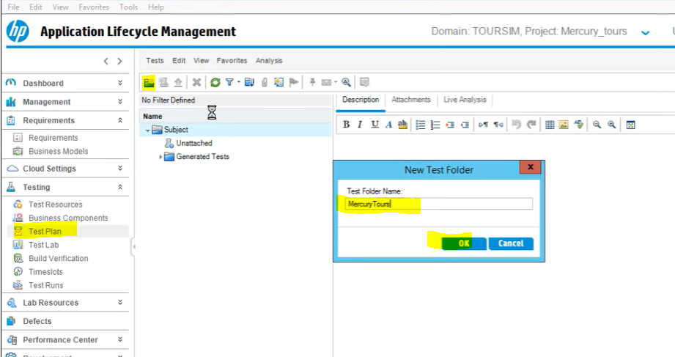

**Click on new test Case icon**

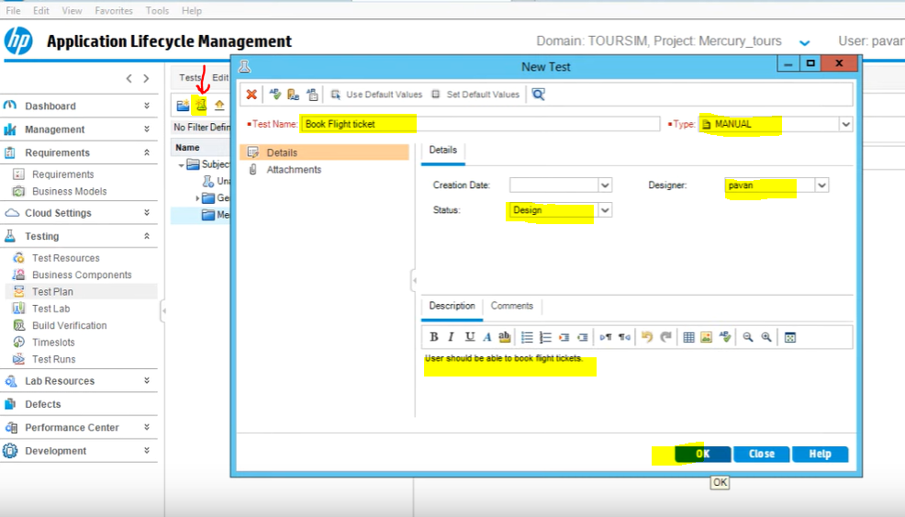

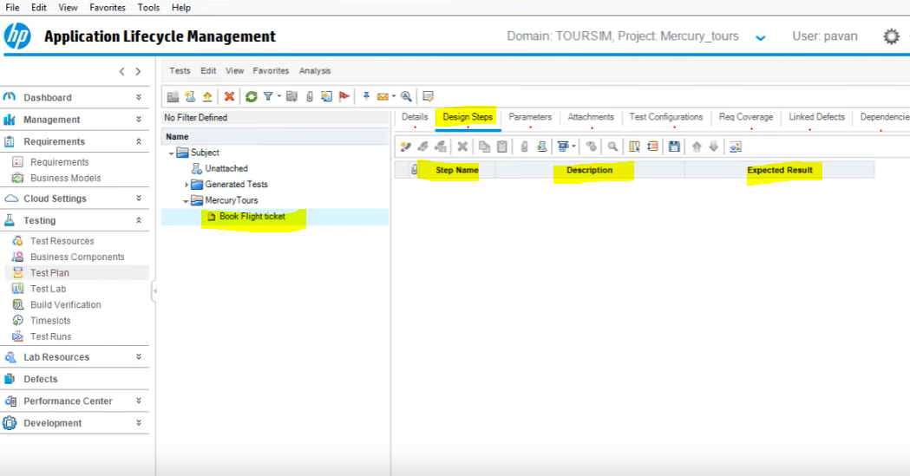

**Design Steps**

* **You can write the test steps manually**
* **You can also import the test steps**

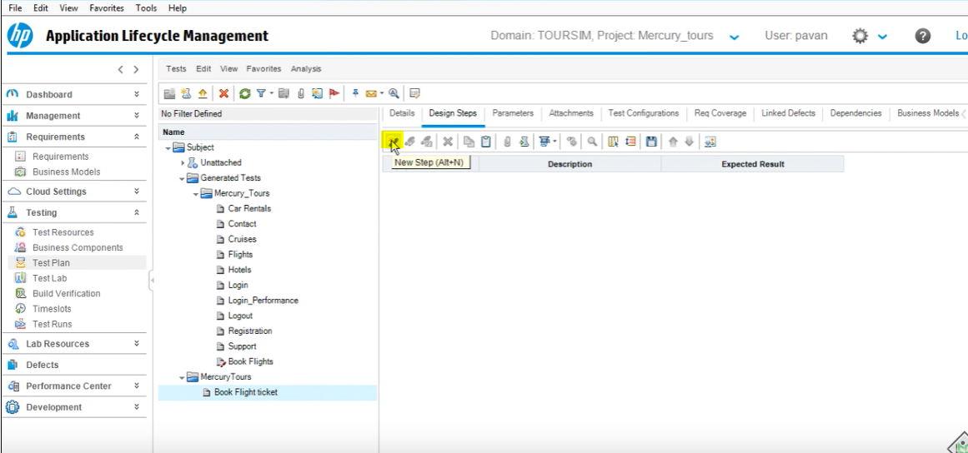

**Step 1**

Enter the step 1 name, steps and expected results

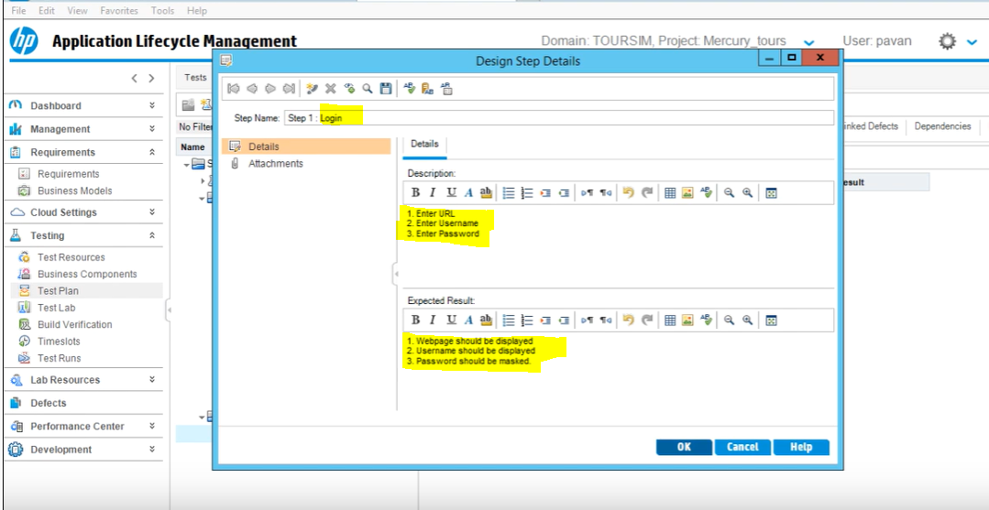

**As we did in step 1, we need to complete all the steps until we book a flight ticket and logout**

